Introduction (Simple Explanation in Easy English)
The Java Collections Framework has two main parts:

1. Collections
A Collection means a group of items stored together as one unit.
👉 Simple meaning:
Instead of storing one value, you store many values in one place.
Examples:
- List of students
- Set of employee IDs
- Map of country and capital

2. Framework
A Framework is a ready-made structure made of classes and interfaces.
It helps developers perform tasks in a standard and easy way.
👉 Simple meaning:
It is like a toolkit that already has useful code, so you don’t need to write everything from scratch.
Examples:
- Java I/O Framework (for input/output operations)
- Java Concurrency Framework (for multithreading)
- Java Stream API (introduced in Java 8)
- JDBC API (for database connectivity)

Definition
The Collections Framework is a unified architecture (a well-organized system) used to store and manage groups of data.
👉 Simple meaning:
It gives a standard way to handle data like lists, sets, and maps.

It Provides
1. Interfaces
These define what operations can be done.
Examples:
- List
- Set
- Queue
- Map
👉 Simple meaning:
They are like rules or blueprints.

2. Implemented Classes
These are actual classes that perform the work.
Examples:
- ArrayList
- HashSet
- HashMap
👉 Simple meaning:
These are ready-to-use tools.

3. Algorithms
These are built-in methods to perform common operations.
Examples:
- Sorting
- Searching
- Shuffling
These are provided by the Collections class.
👉 Simple meaning:
They help you process data easily without writing complex code.

Main Goal
The main goal of the Collections Framework is:
✔ To make data handling in Java
- Easy
- Efficient
- Standardized

Hierarchy of collection framework:
============================

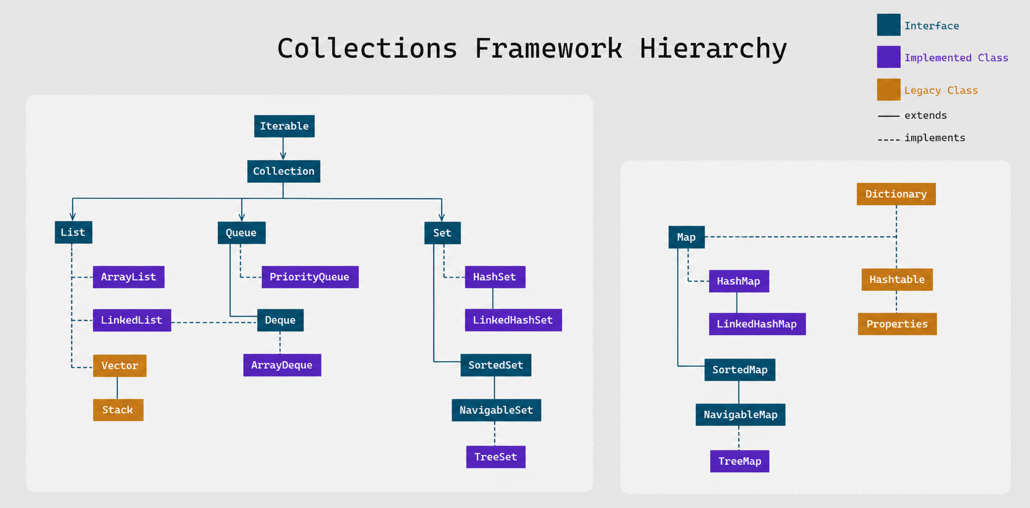

Hierarchy of Collections Framework (Simple Explanation)

The Java Collections Framework is mainly divided into two important interfaces:

1. Collection

The Collection interface represents a group of objects.

👉 Simple meaning:
It is used when you want to store multiple items together.

Examples:
- List (ordered data, allows duplicates)
- Set (no duplicates allowed)
- Queue (follows order like FIFO – First In First Out)

2. Map

The Map interface is used to store data in key-value pairs.

👉 Simple meaning:
Each value is stored with a unique key (like a dictionary).

Example:
- Country → Capital
- ID → Name

⚠️ Important Note:
Map does NOT extend Collection.

👉 Simple meaning:
Even though it is part of the framework, it is separate from Collection.

Hierarchy (Understanding in Simple Way)

👉 Think like this:
- At the top → Interfaces (Collection, Map)
- Below → Sub-interfaces (List, Set, Queue)
- Below that → Classes (ArrayList, HashSet, HashMap, etc.)

👉 Simple meaning:
It is like a tree structure where:
- Interfaces = rules
- Classes = actual working tools

Tip (Legacy Classes)

Some older classes are still part of the framework:
- Vector
- Stack
- Hashtable
- Properties
- Dictionary

👉 Simple meaning:
These are old classes, but still exist to support older code (backward compatibility).

Main Packages in Collections Framework
- java.util.Collection package
- java.util.Map package

👉 Simple meaning:
These packages contain all the interfaces and classes used in collections.

Uses of Collections Framework (Simple Explanation)

1. Storing Data

Use ArrayList or LinkedList

👉 Example:
Store students, products, or items in a list.

2. Processing Queues

Use Queue or Deque

👉 Example:
Managing print jobs or task scheduling (first come, first serve).

3. Managing Unique Data

Use HashSet or TreeSet

👉 Example:
Store unique employee IDs (no duplicates allowed).

4. Key-Value Mapping

Use HashMap or TreeMap

👉 Example:
Country → Capital mapping.

5. Sorting and Searching

Use methods from the Collections class

👉 Example:
- Sorting data
- Searching elements
- Shuffling data

👉 Simple meaning:
No need to write your own logic; Java gives ready-made methods.

Advantages of Collections Framework (Simple Explanation)

1. Reusability

You can directly use ready-made classes like:
- ArrayList
- HashMap

👉 Simple meaning:
No need to write code from scratch.

2. Efficiency

Collections are optimized for:
- Storing
- Retrieving
- Manipulating data

👉 Simple meaning:
They work fast and efficiently.

3. Consistency

Provides a standard way of coding.

👉 Simple meaning:
Your code becomes easy to read and maintain.

4. Flexibility

Supports different types of collections:
- List
- Set
- Map

👉 Simple meaning:
You can choose the best structure based on your need.

5. Thread-Safety (Optional)

Some classes are synchronized:
- Vector
- Hashtable

👉 Simple meaning:
They are safe to use in multithreading environments.

What is Collection?

The Collection interface is an interface present in the java.util package.

👉 Simple meaning:
It is a blueprint (rule book) for storing and handling a group of objects.

public interface Collection<E> extends Iterable<E> { }

👉 Simple meaning:
- interface → It only gives rules, not full implementation

What does <E> mean in Collection<E>?

In Java Generics, the <E> is called a generic type parameter.

Simple Meaning

<E> means “Element” (any type of object)

👉 It is just a placeholder name
👉 It tells Java: “This collection will store objects of a specific type”

Why do we use <E>?

To make collections:
- Type-safe (no wrong data types)
- Flexible (can store any type)

Example 1: Without Generics (Old Way)

Collection c = new ArrayList();
c.add("Hello");
c.add(10); // Allowed ❌ (mixed types)

👉 Problem:
You can store anything → may cause errors later

Example 2: With Generics (<E>)

Collection<String> c = new ArrayList<>();
c.add("Hello");
c.add("World");
// c.add(10); ❌ Error

👉 Now:
- Only String values allowed
- No mistakes → safer code ✅

What exactly is E?

👉 E is just a name, not a keyword

Common naming:
- E → Element (used in collections)
- T → Type
- K → Key (in Map)
- V → Value (in Map)

Behind the Scenes

When you write:

Collection<String>

👉 Java internally replaces E with String

So it becomes:

👉 “This collection stores only Strings”

Collection<E>?

In Java Generics, the <E> is called a generic type parameter.

Simple Meaning

<E> means “Element” (any type of object)

👉 It is just a placeholder name
👉 It tells Java: “This collection will store objects of a specific type”

Why do we use <E>?

To make collections:
- Type-safe (no wrong data types)
- Flexible (can store any type)

Example 1: Without Generics (Old Way)

Collection c = new ArrayList();
c.add("Hello");
c.add(10); // Allowed ❌ (mixed types)

👉 Problem:
You can store anything → may cause errors later

Example 2: With Generics (<E>)

Collection<String> c = new ArrayList<>();
c.add("Hello");
c.add("World");
// c.add(10); ❌ Error

👉 Now:
- Only String values allowed
- No mistakes → safer code ✅

What exactly is E?

👉 E is just a name, not a keyword

Common naming:
- E → Element (used in collections)
- T → Type
- K → Key (in Map)
- V → Value (in Map)

Behind the Scenes

When you write:

Collection<String>

👉 Java internally replaces E with String

So it becomes:

👉 “This collection stores only Strings”

Very Simple Analogy

Think of <E> like a label on a box 📦
- Collection<String> → Box only for Strings
- Collection<Integer> → Box only for numbers

👉 You cannot mix items in the wrong box

Final One-Line Understanding

<E> means:
👉 “This collection will store elements of a specific type”

If you want, next I can explain how Generics work internally (type erasure) in very simple way, which is often asked in interviews.

extends Iterable<E> explin this in same way

extends Iterable<E> (Simple + Deep Explanation)

In this line:

public interface Collection<E> extends Iterable<E>

the Iterable interface is very important.

What does extends Iterable<E> mean?

👉 Simple meaning:
It means Collection can be used to loop (iterate) over elements.

What is Iterable?

Iterable is an interface that allows objects to be used in loops.

👉 Simple meaning:
If a class implements Iterable, you can go through its elements one by one.

Why Collection extends Iterable?

Because all collections store multiple elements, and we usually need to:
- Read elements
- Process elements
- Loop through elements

👉 So Java made Collection extend Iterable.

What do we get from Iterable?

It provides a method:

Iterator<E> iterator();

👉 Simple meaning:
This method gives an Iterator, which helps to move through elements one by one.

Example using for-each loop

List<String> list = new ArrayList<>();
list.add("A");
list.add("B");
list.add("C");
for(String s : list){
System.out.println(s);
}

👉 This works because Collection extends Iterable

Without Iterable (Important Understanding)

If Collection did NOT extend Iterable:

❌ You cannot use:

for(String s : list)

👉 You would have to manually use iterators every time.

How it works internally (Simple)

When you write:

for(String s : list)

👉 Java internally does:

Iterator<String> it = list.iterator();
while(it.hasNext()){
String s = it.next();
}

What does <E> mean here?

Same as before:

👉 <E> = type of elements (String, Integer, etc.)

So:
- Iterable<E> → works with any type
- Collection<E> → passes that same type to Iterable

